ĐẠI HỌC BÁCH KHOA HÀ NỘI
TRƯỜNG CÔNG NGHỆ THÔNG TIN VÀ TRUYỀN THÔNG

BÁO CÁO THỰC HÀNH
IT3103-744528-2024.1
BÀI THỰC HÀNH 5

Họ và tên sv: Nguyễn Đức Hậu
MSSV: 20225834
Lớp: Việt Nhật 03 – K67
GVHD: Lê Thị Hoa
HTGD: Đặng Mạnh Cường

Hà Nội 12/2024

BÁO CÁO THỰC HÀNH LAB 5
LẬP TRÌNH HƯỚNG ĐỐI TƯỢNG
Contents
Table of Contents
1. Swing components 6
1.1 AWTAccumulator 6
1.2 SwingAccumulator 7
2 Organizing Swing components with Layout Managers 8
2.1 Code 8
2.2 Demo 10
3 Create a graphical user interface for AIMS with Swing 11
3.1 Create class StoreScreen 11
3.2 Create class MediaStore 15
3.3 Demo 17
4 JavaFX API 20
4.1 Create class Painter 20
4.2 Create Painter.fxml 22
4.3 Create class PainterController 22
5 View Cart Screen 24
5.1 Create cart.fxml 24
5.2 Create class CartScreen 27
5.3Create class CartScreenController 27
5.4 Demo 30
6 Updating buttons based on selected item in TableView – ChangeListener 31
6.1 Edit class CartScreenController 31
6.2 Demo 31
7 Deleting a media 33
7.1 Code 33
7.2 Demo 34
8.Complete the Aims GUI application 36
9.Use case Diagram 42
10. Class Diagram 44
Figure 8.9: Exception 44

Table of Figure
Figure 1.1: Source code of AWTAccumulator 4
Figure 1.2: Source code of SwingAccumulator 6
Figure 2.1: Source code of NumberGrid 1 7
Figure 2.2: Source code of NumberGrid 2 8
Figure 2.3: Demo DEL button 9
Figure 2.4: Demo C button 10
Figure 3.1: Class StoreScreen 1 11
Figure 3.2: Class StoreScreen 2 12
Figure 3.3: Class StoreScreen 3 12
Figure 3.4: Class StoreScreen 4 13
Figure 3.5: Class StoreScreen 5 13
Figure 3.6: Class StoreScreen 6 14
Figure 3.7: Class MediaStore 1 14
Figure 3.8: Class MediaStore 2 15
Figure 3.9: Class MediaStore 3 15
Figure 3.10: StoreScreen 16
Figure 3.11 Demo Add to cart button 17
Figure 3.12 Demo Play button 18
Figure 3.13 Demo View cart button 19
Figure 4.1: Class Painte 20
Figure 4.2: Painter.fxml 1 21
Figure 4.3: Painter.fxml 2 21
Figure 4.4: PainterController 22
Figure 5.1: Cart.fxml 1 24
Figure 5.2: Cart.fxml 2 24
Figure 5.3: Cart.fxml 3 24
Figure 5.4: CartScreen class 26
Figure 5.5: CartScreenController 1 26
Figure 5.6: CartScreenController 2 27
Figure 5.7: Demo CartScreen 29
Figure 6.1: CartScreenController 1 30
Figure 6.2: CartScreenController 2 30
Figure 6.3: Demo media playable 31
Figure 6.4: Demo media unplayable 32
Figure 7.1: btnRemovePressed Method 33
Figure 7.2: button Remove 34
Figure 7.3: button Remove 35
Figure 8.1: Store before add book 35
Figure 8.2: Add book 36
Figure 8.4: Add CD 37
Figure 8.5: Store after add CD 38
Figure 8.6 Add DVD 39
Figure 8.7: Store after add DVD 40
Figure 8.8: Cart 41

1. Swing components

1.1 AWTAccumulator
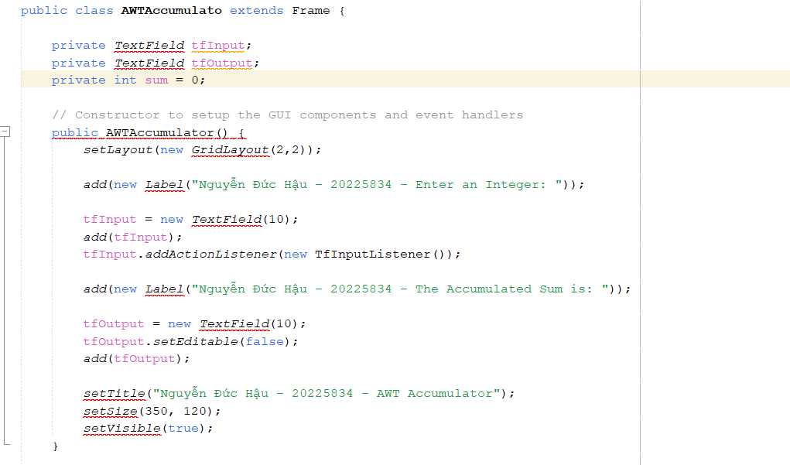

Figure 1.1: Source code of AWTAccumulator

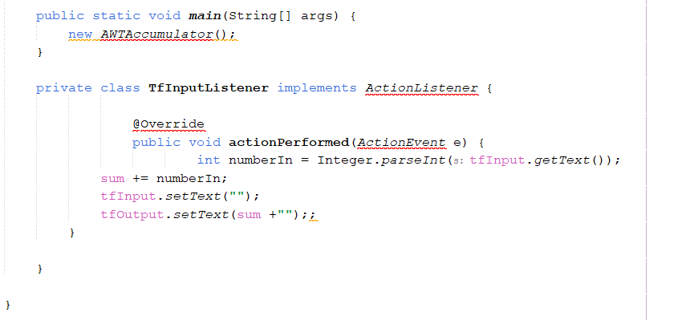

1.2 SwingAccumulator

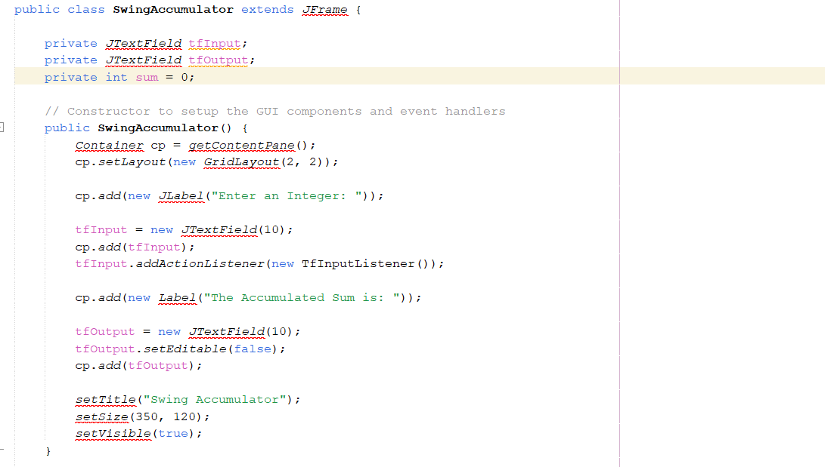

Figure 1.2: Source code of SwingAccumulator

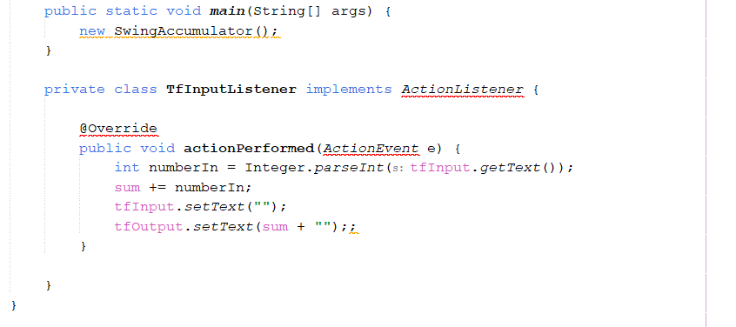

2 Organizing Swing components with Layout Managers

2.1 Code
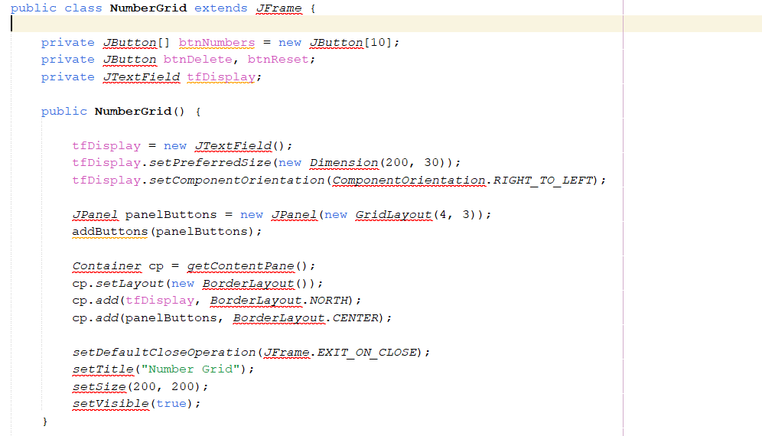

Figure 2.1: Source code of NumberGrid 1

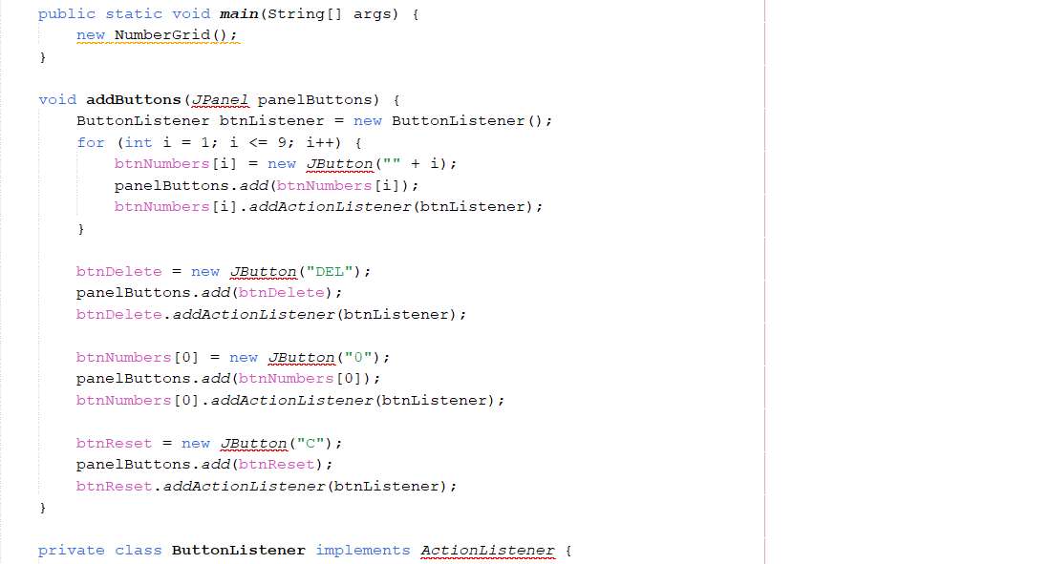

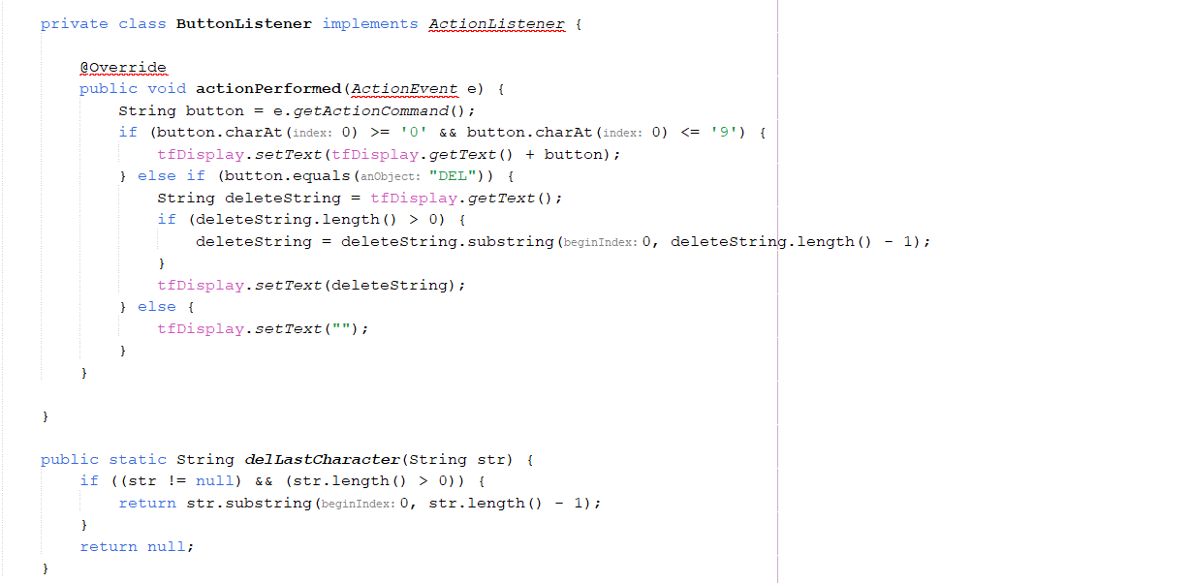

Figure 2.2: Source code of NumberGrid 2

2.2 Demo

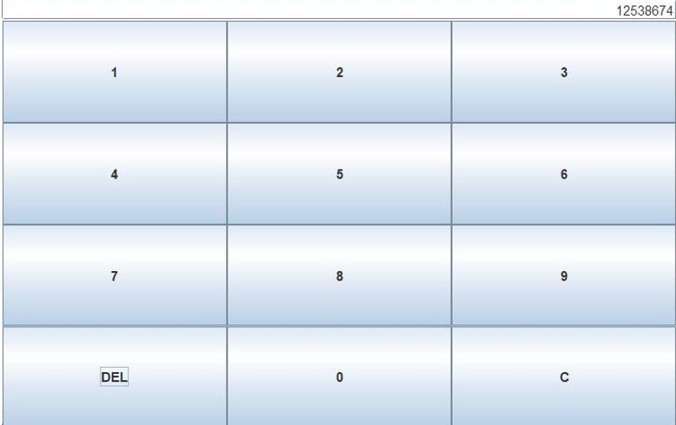

Figure 2.3: Demo DEL button

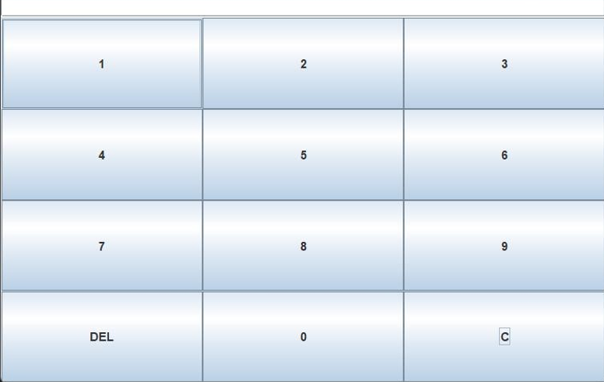

Figure 2.4: Demo C button

3 Create a graphical user interface for AIMS with Swing

3.1 Create class StoreScreen
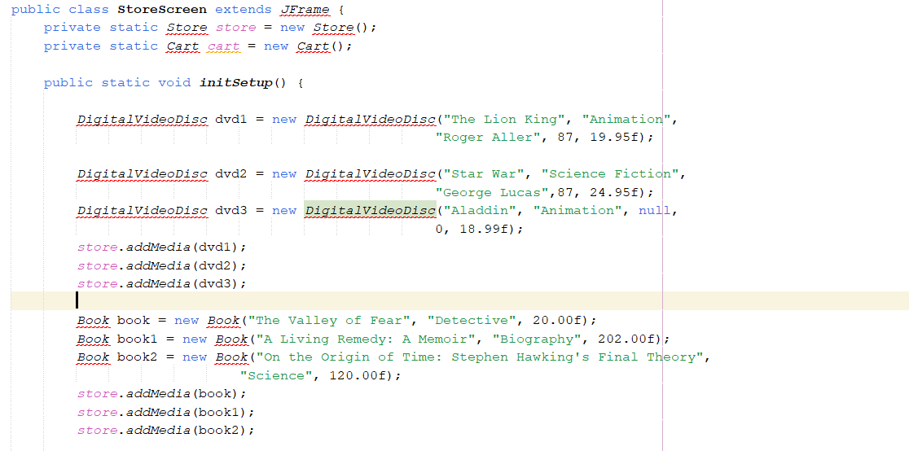

Figure 3.1: Class StoreScreen 1

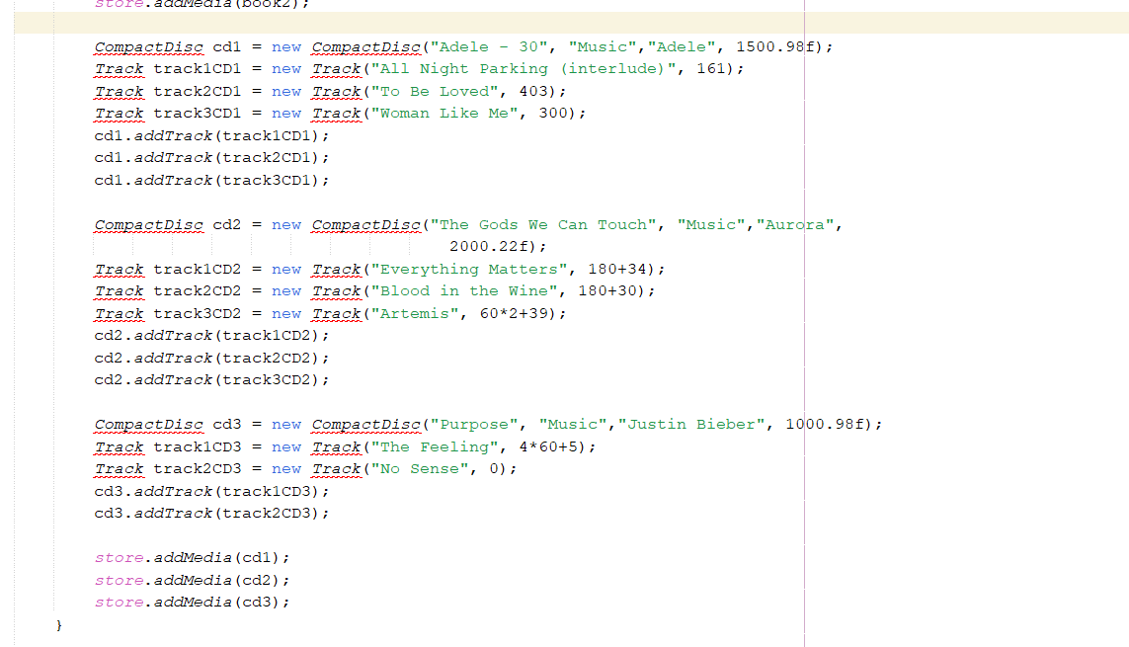

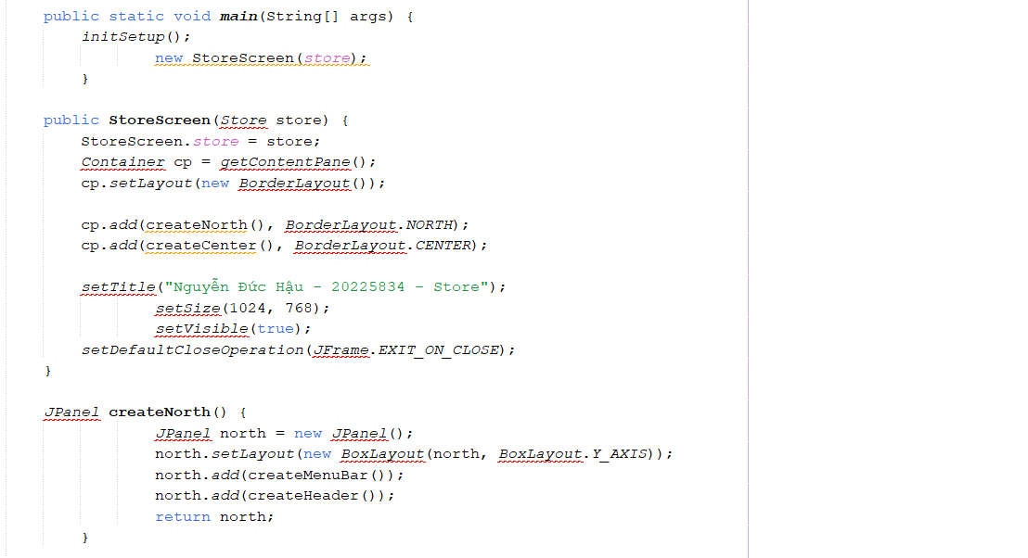

Figure 3.2: Class StoreScreen 2

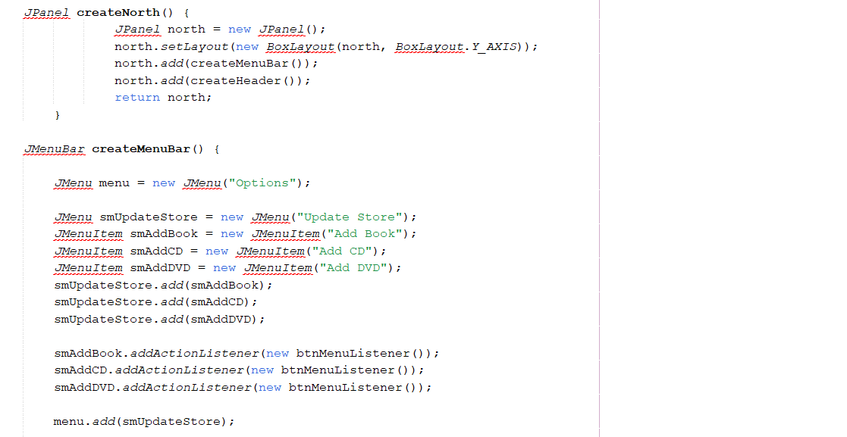

Figure 3.3: Class StoreScreen 3

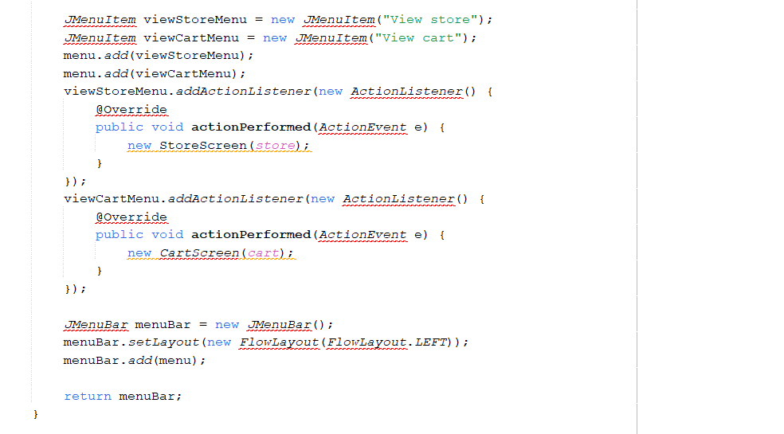

Figure 3.4: Class StoreScreen 4

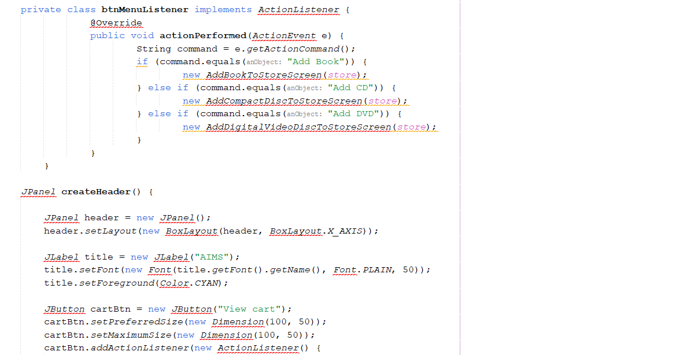

Figure 3.5: Class StoreScreen 5

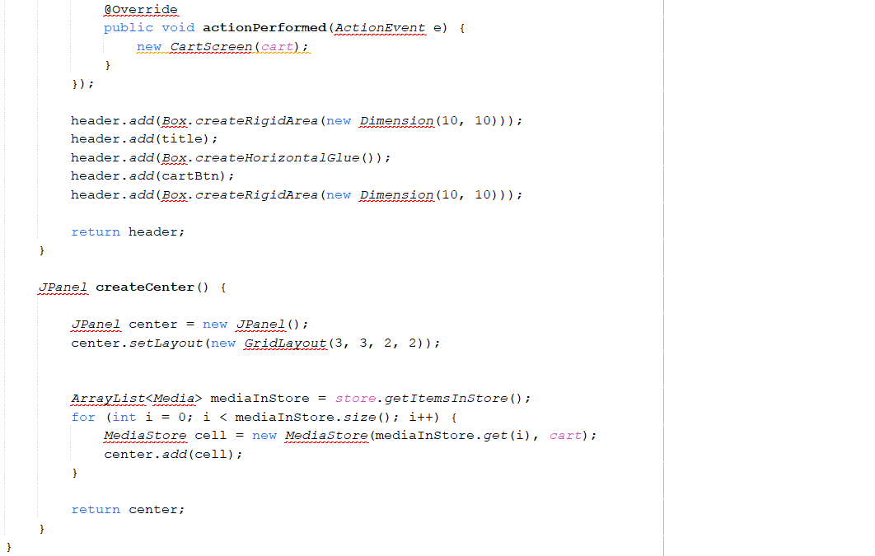

Figure 3.6: Class StoreScreen 6

3.2 Create class MediaStore
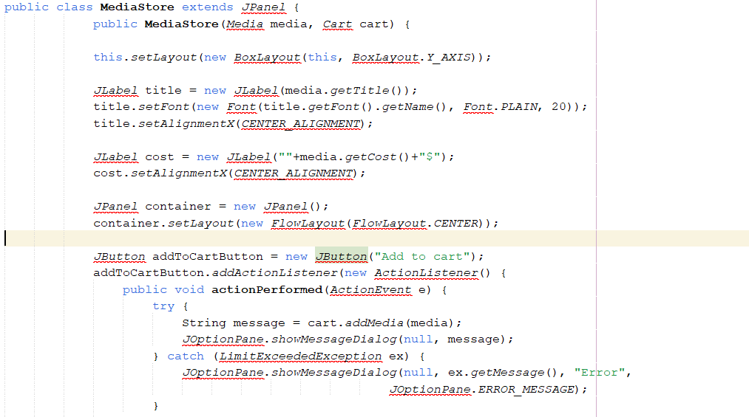

Figure 3.7: Class MediaStore 1

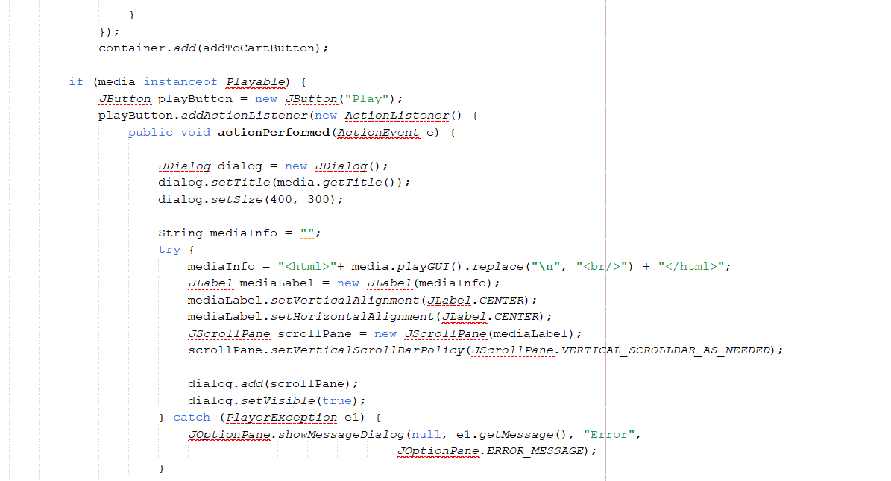

Figure 3.8: Class MediaStore 2
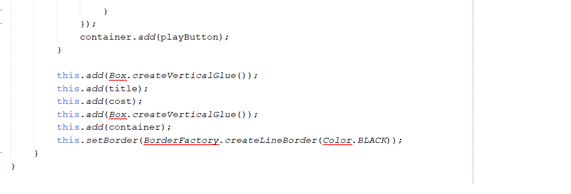

Figure 3.9: Class MediaStore 3

3.3 Demo
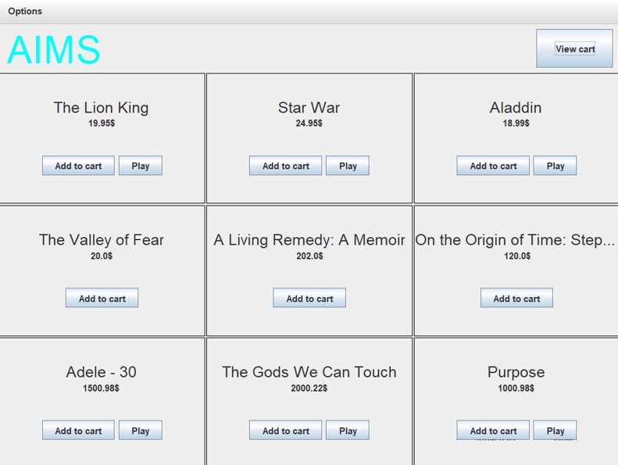

Figure 3.10: StoreScreen

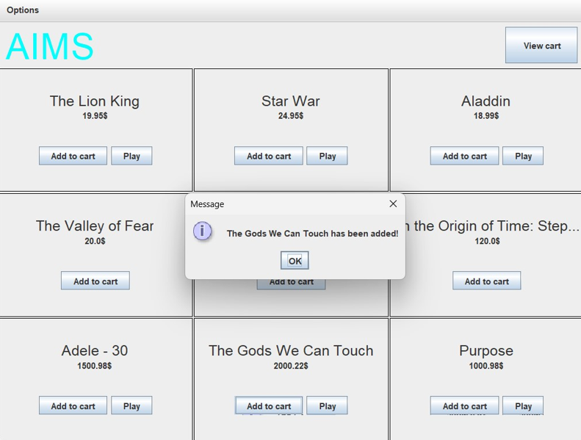

Figure 3.11 Demo Add to cart button

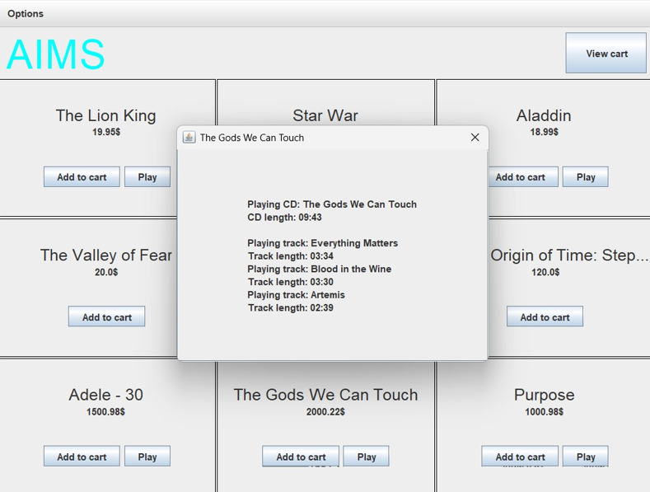

Figure 3.12 Demo Play button

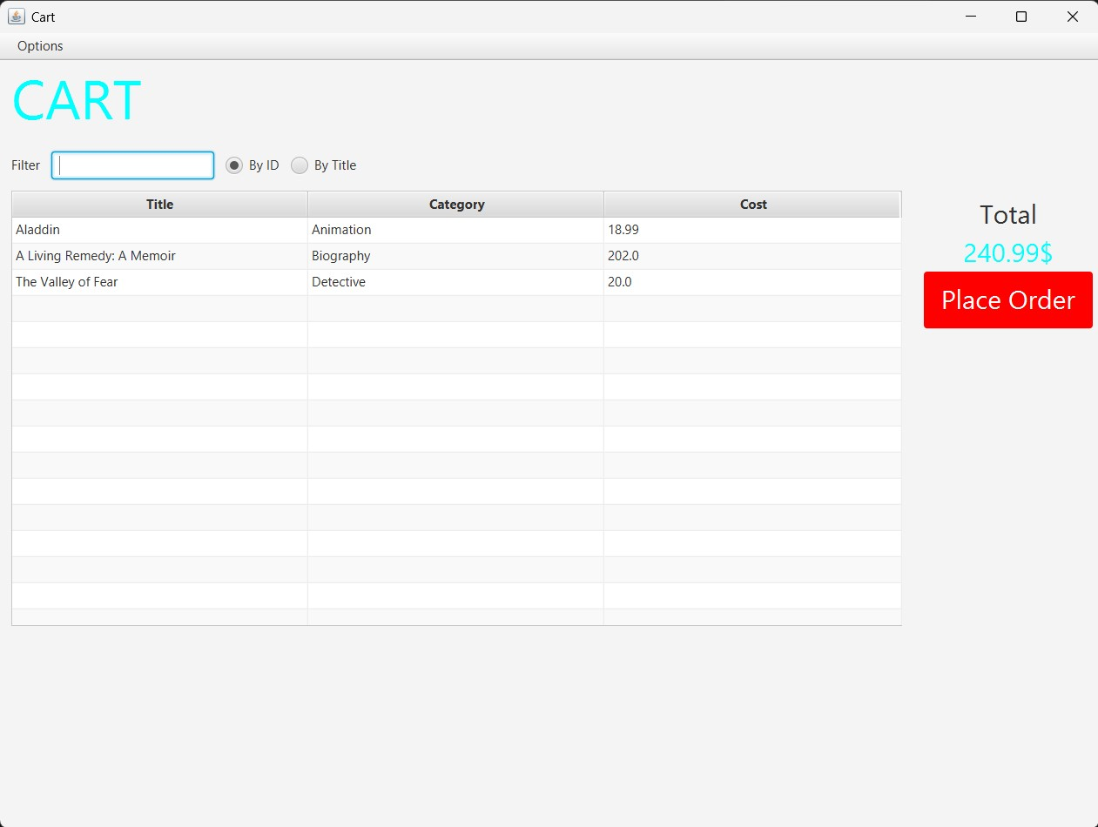

Figure 3.13 Demo View cart button

4 JavaFX API

4.1 Create class Painter

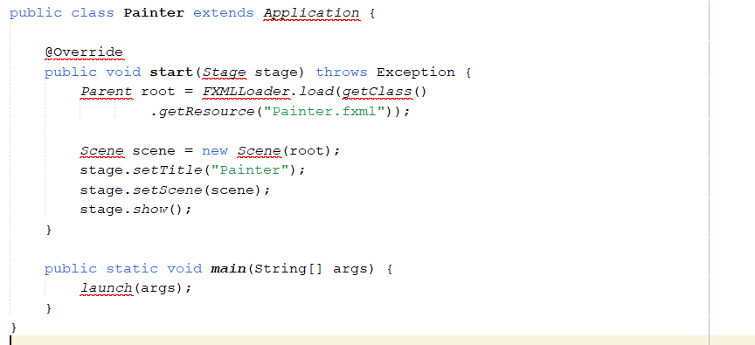

Figure 4.1: Class Painte

4.2 Create Painter.fxml

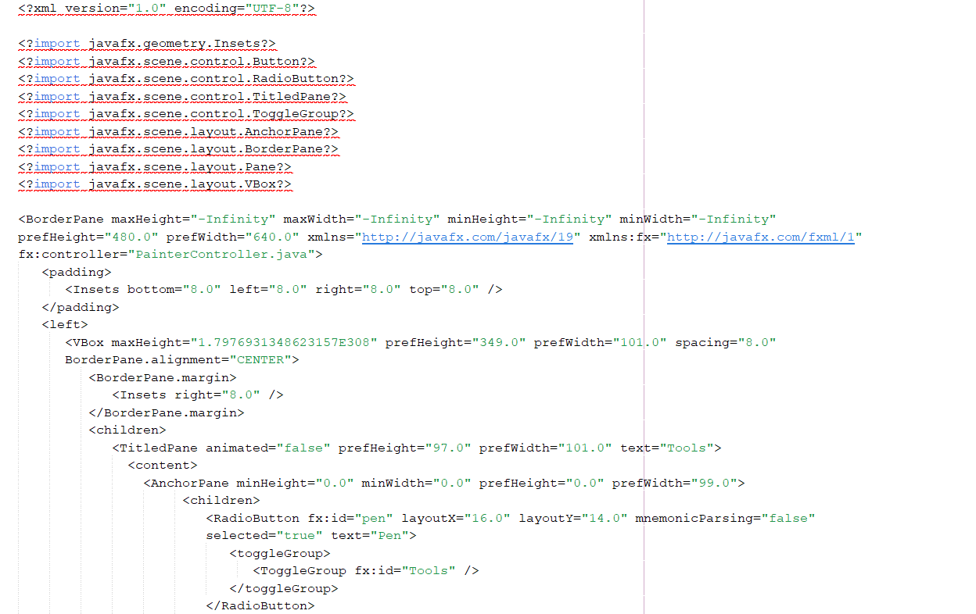

Figure 4.2: Painter.fxml 1

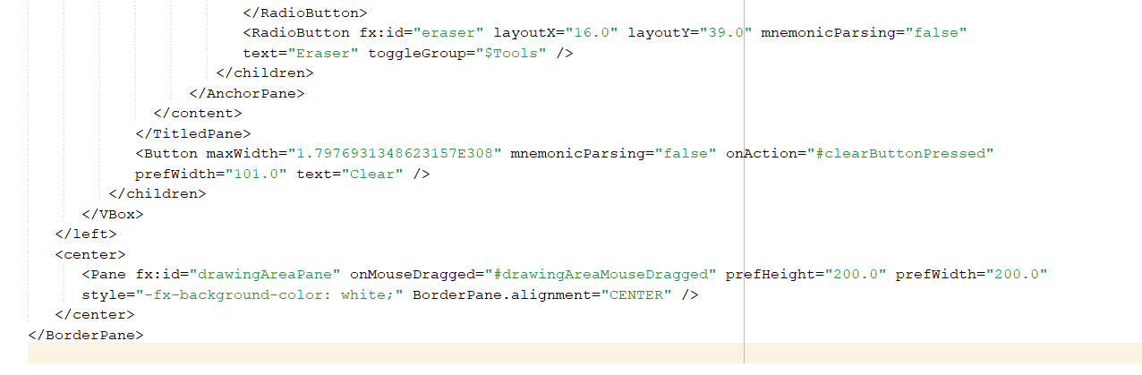

Figure 4.3: Painter.fxml 2

4.3 Create class PainterController

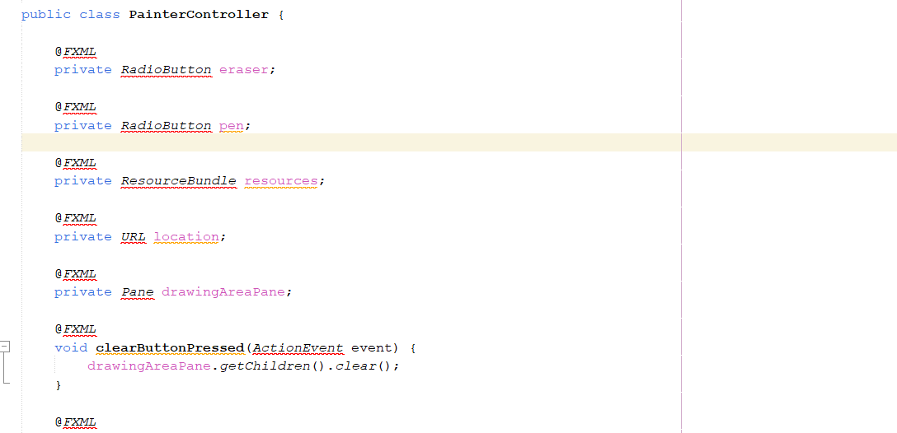

Figure 4.4: PainterController

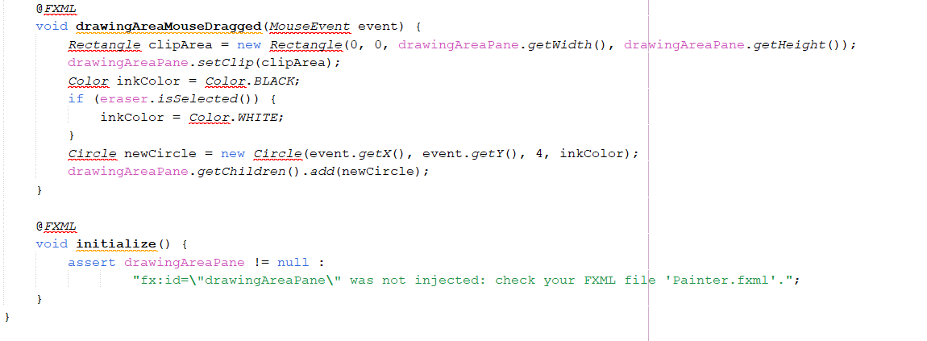

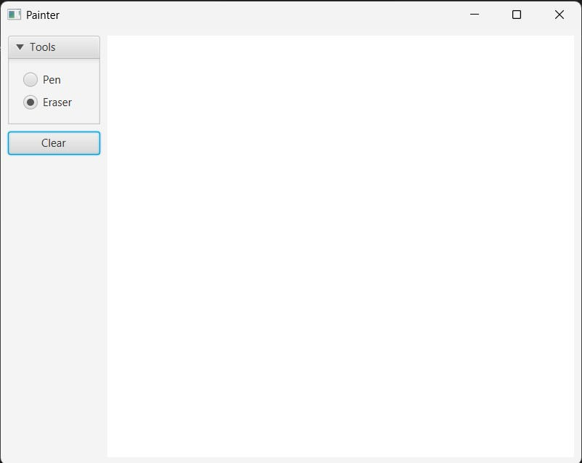

5 View Cart Screen

5.1 Create cart.fxml
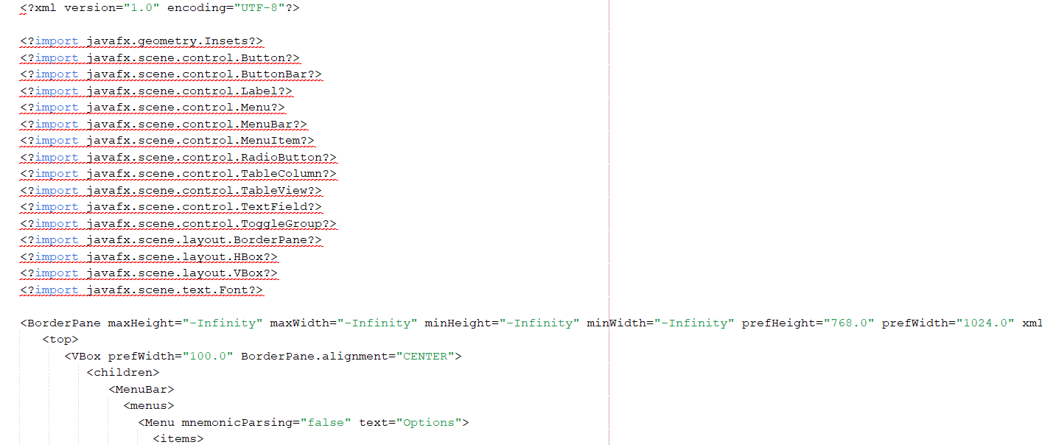

Figure 5.1: Cart.fxml 1

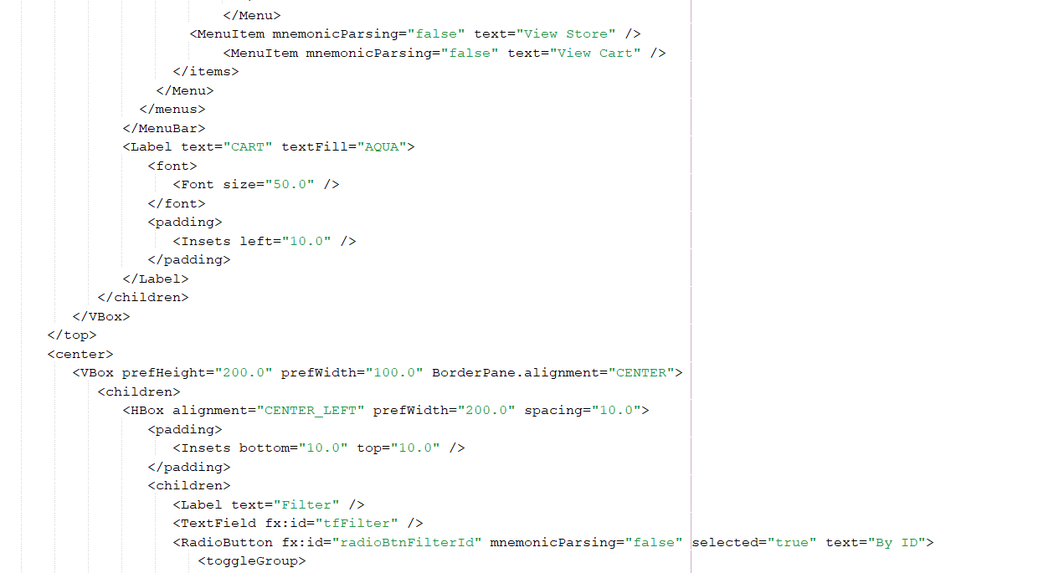

Figure 5.2: Cart.fxml 2

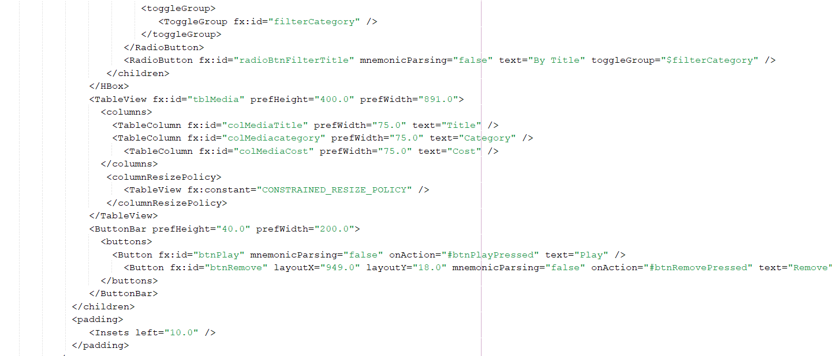

Figure 5.3: Cart.fxml 3
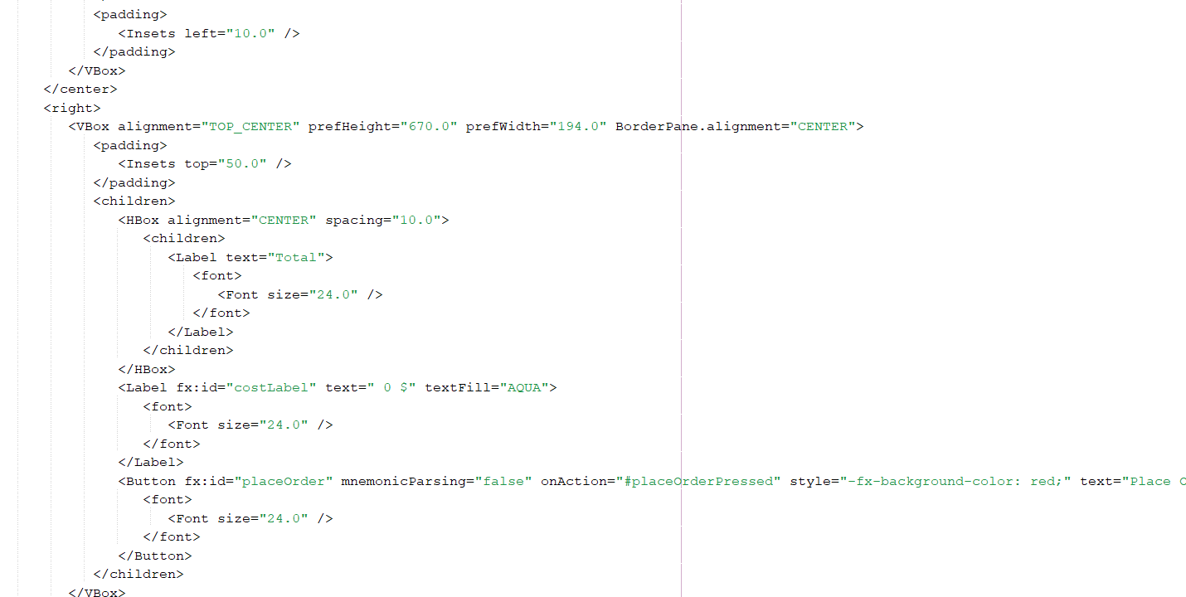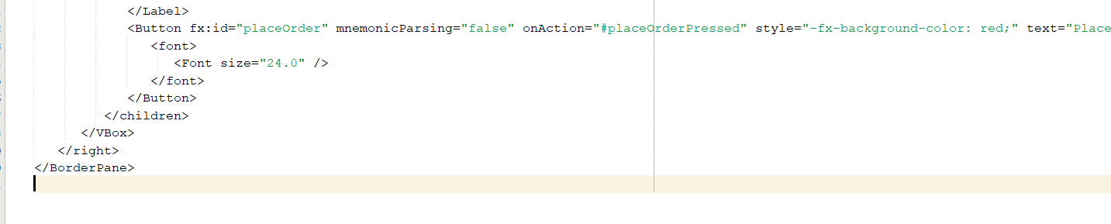

5.2 Create class CartScreen
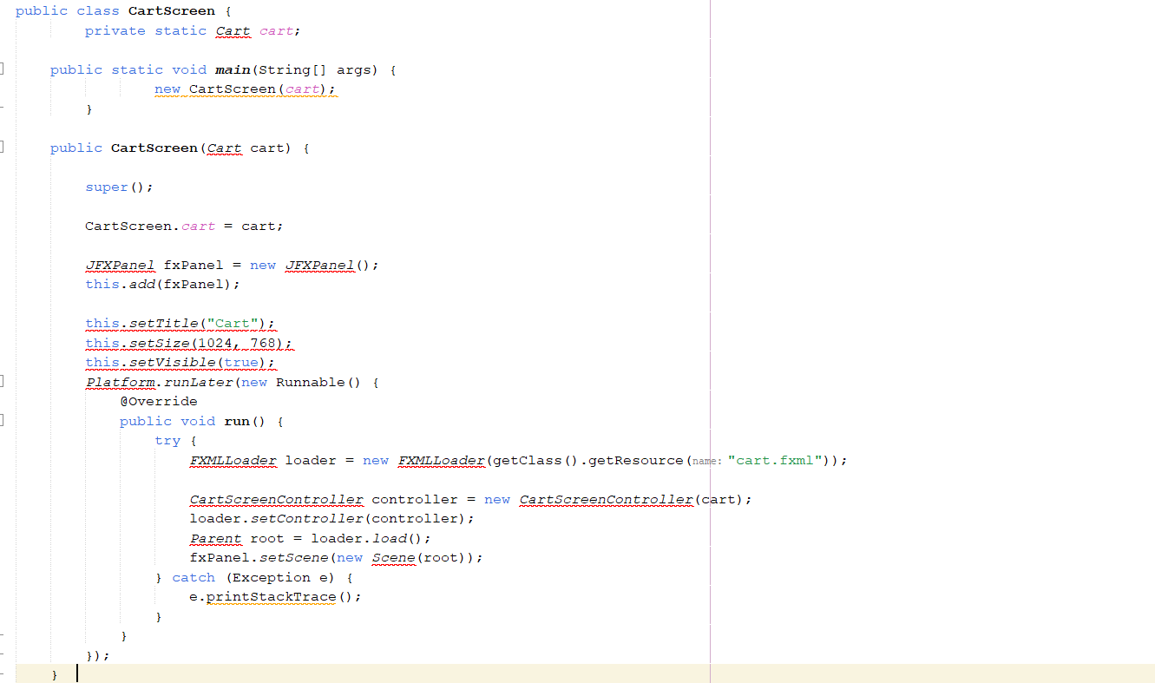

Figure 5.4: CartScreen class

5.3Create class CartScreenController
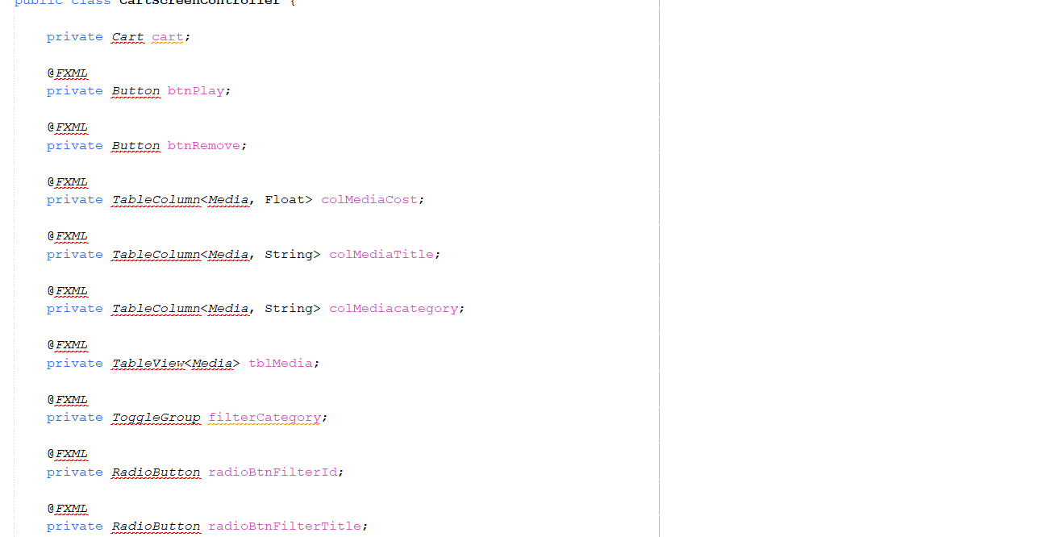

Figure 5.5: CartScreenController 1

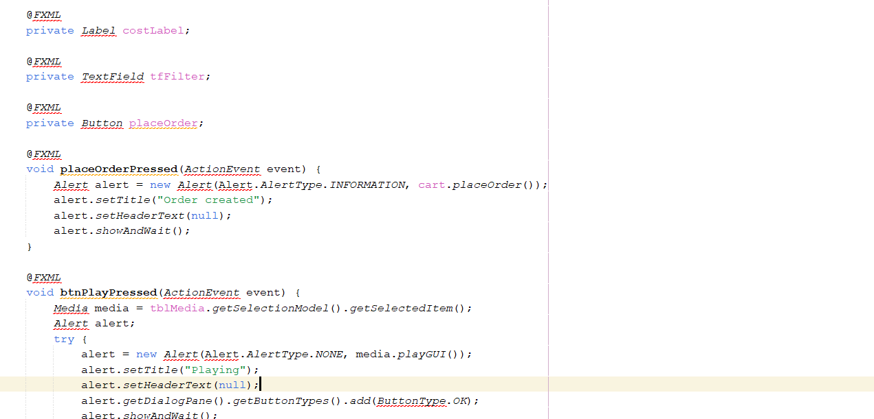

Figure 5.6: CartScreenController 2

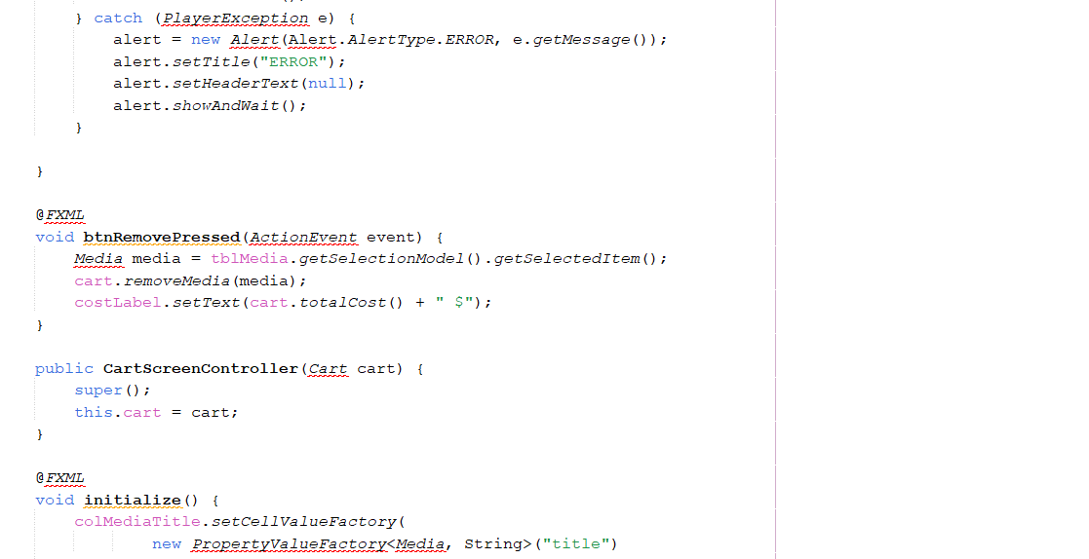

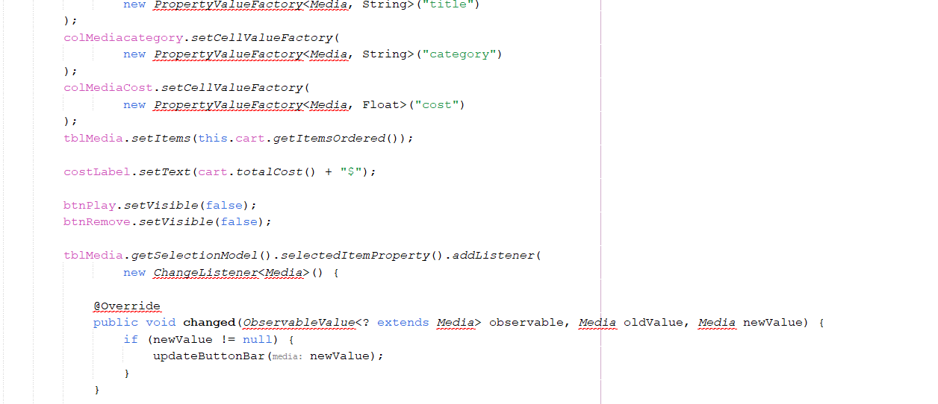

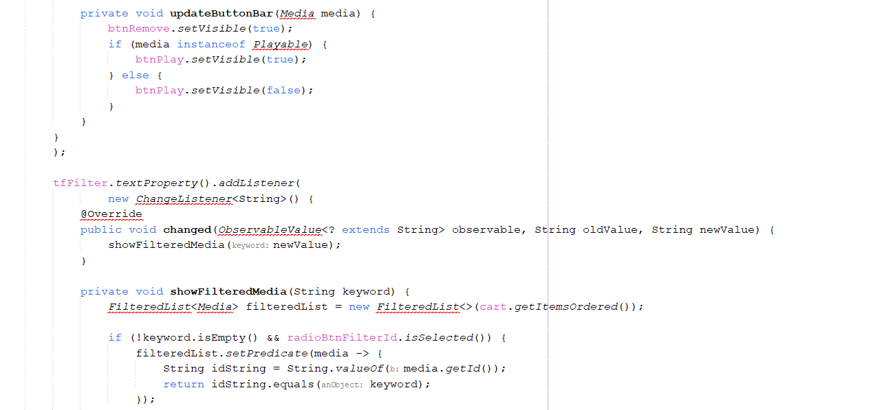

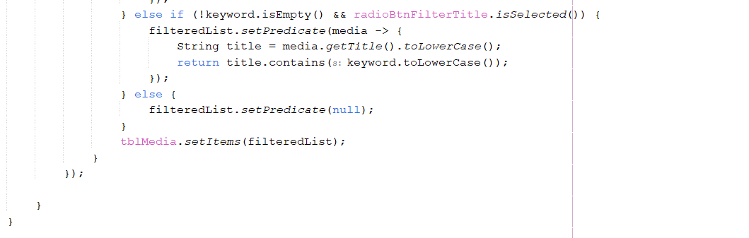

5.4 Demo


Figure 5.7: Demo CartScreen

6 Updating buttons based on selected item in TableView – ChangeListener

6.1 Edit class CartScreenController
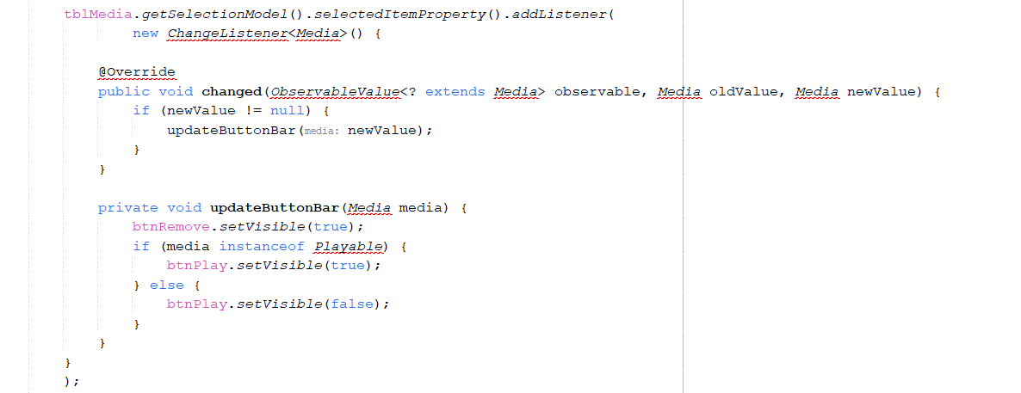

Figure 6.1: CartScreenController 1

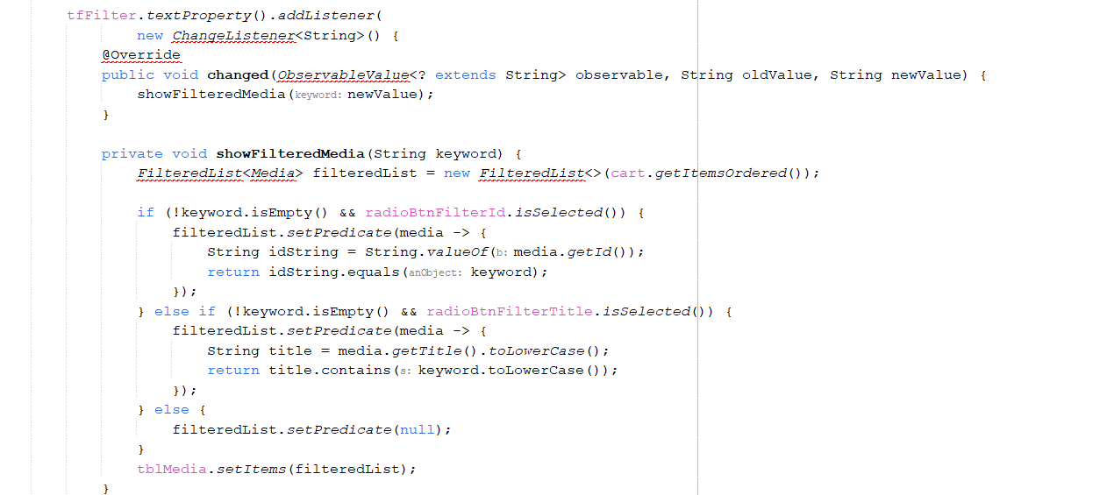

Figure 6.2: CartScreenController 2

6.2 Demo

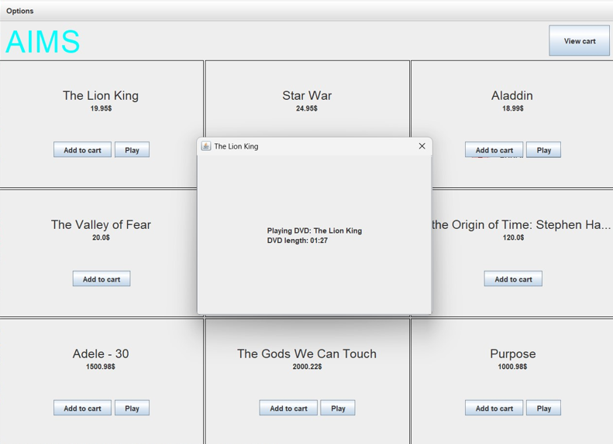

Figure 6.3: Demo media playable

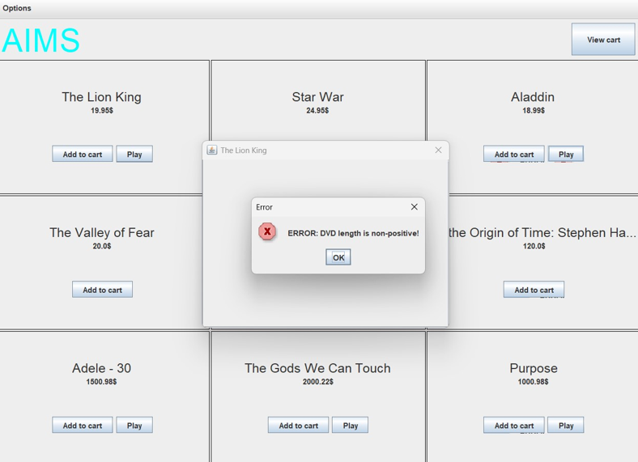

Figure 6.4: Demo media unplayable

7 Deleting a media

7.1 Code
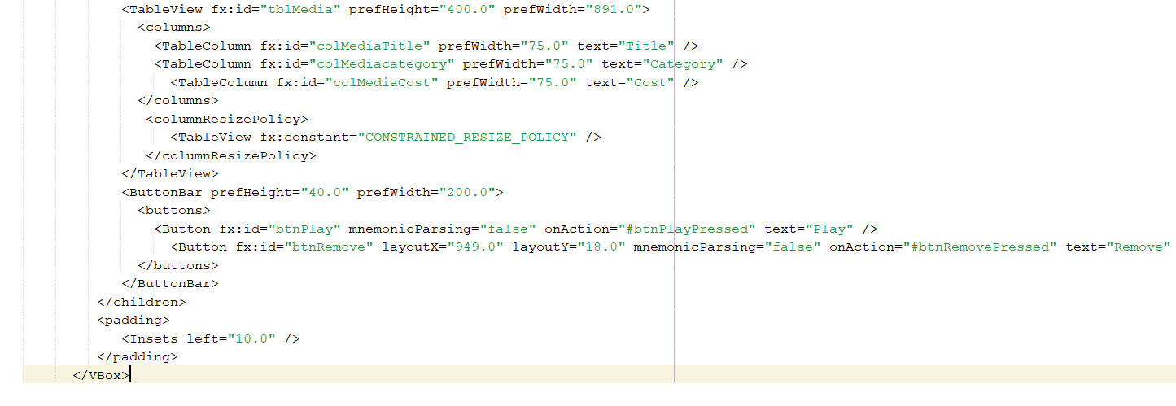

Figure 7.1: btnRemovePressed Method

7.2 Demo
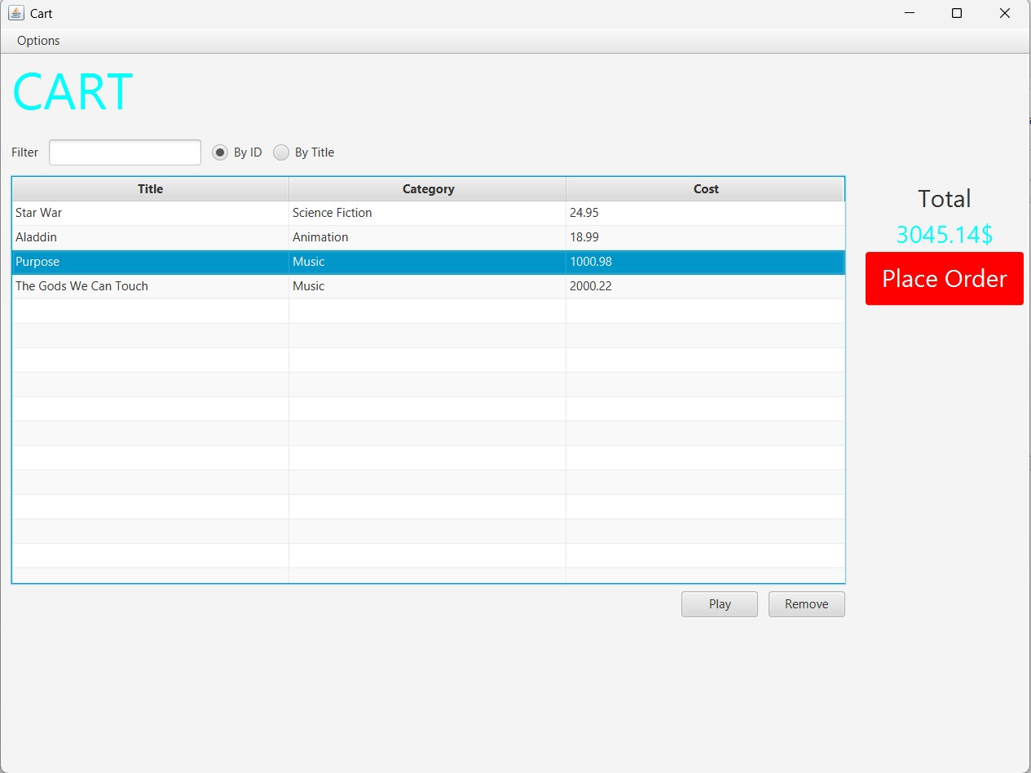

Figure 7.2: button Remove
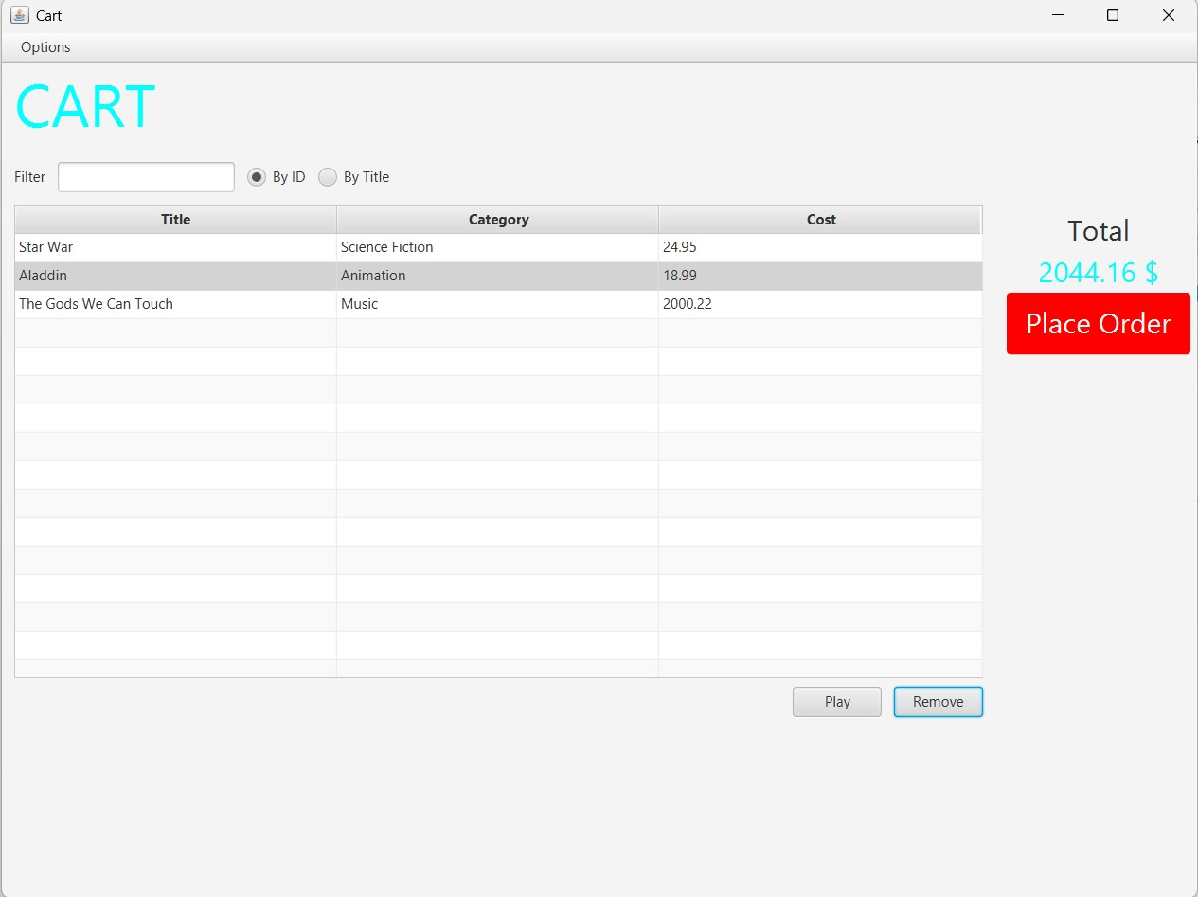

Figure 7.3: button Remove

8.Complete the Aims GUI application
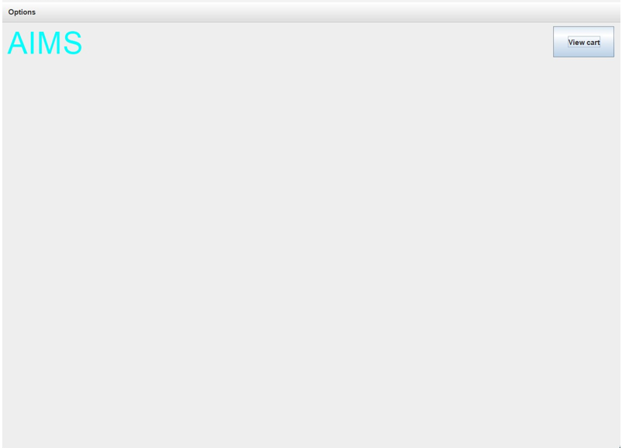

Figure 8.1: Store before add book

Figure 8.2: Add book
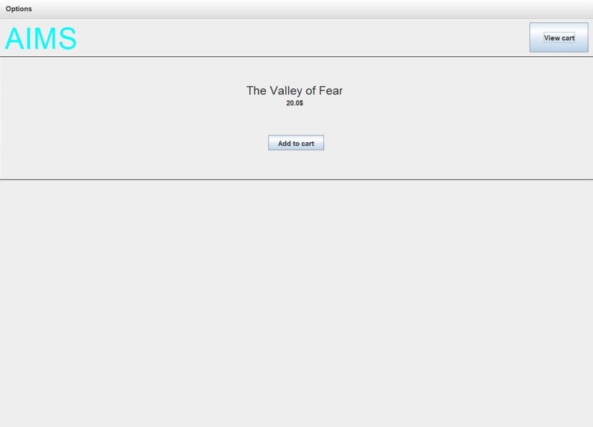
Figure 8.3: Store after add book
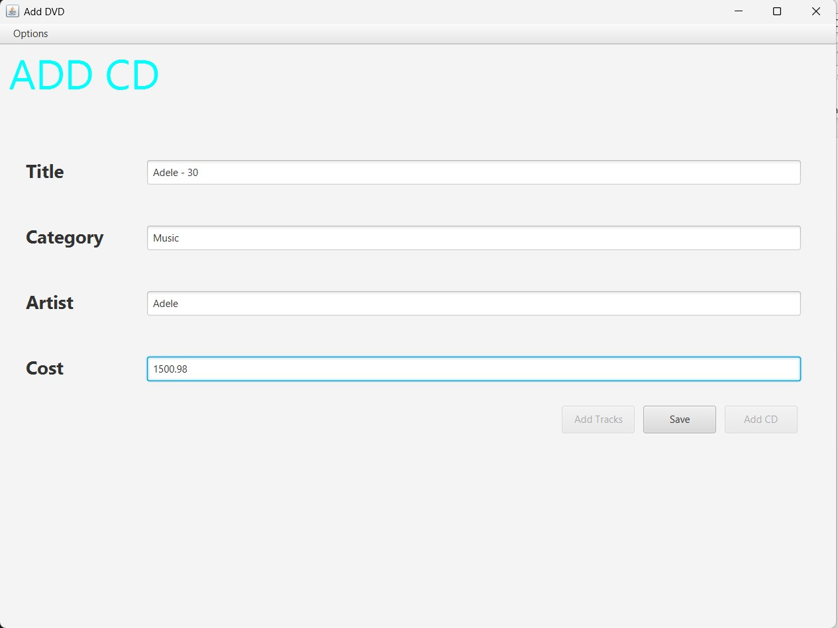

Figure 8.4: Add CD

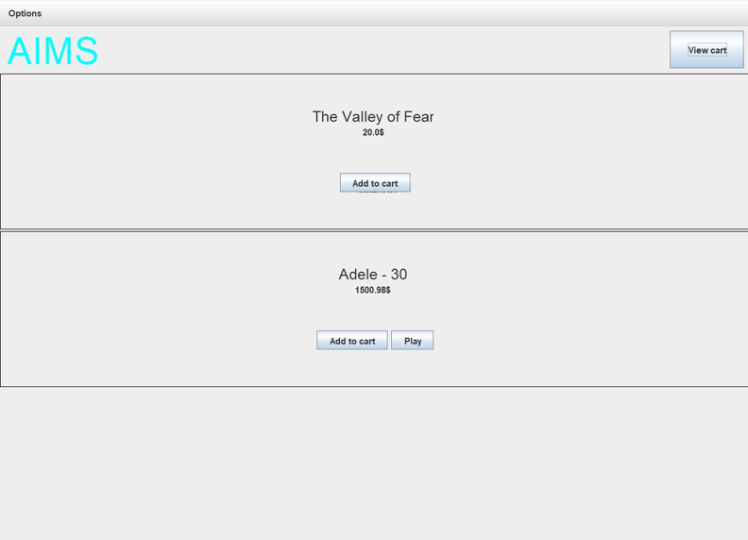

Figure 8.5: Store after add CD

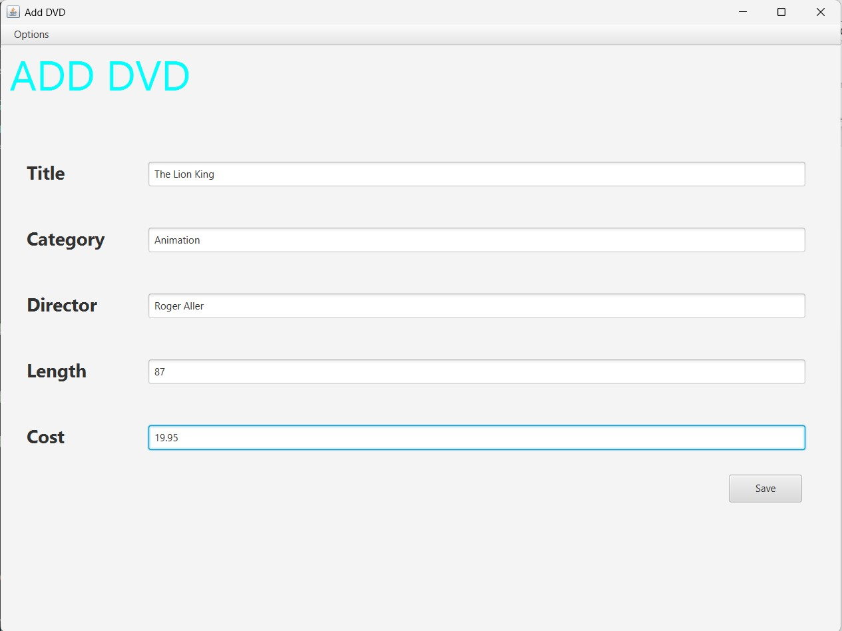

Figure 8.6 Add DVD

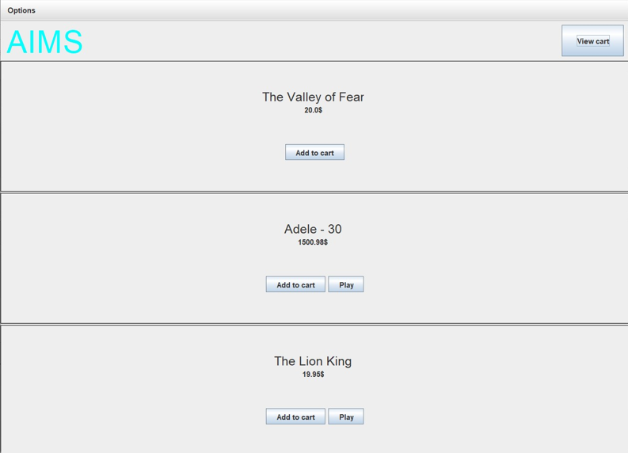

Figure 8.7: Store after add DVD

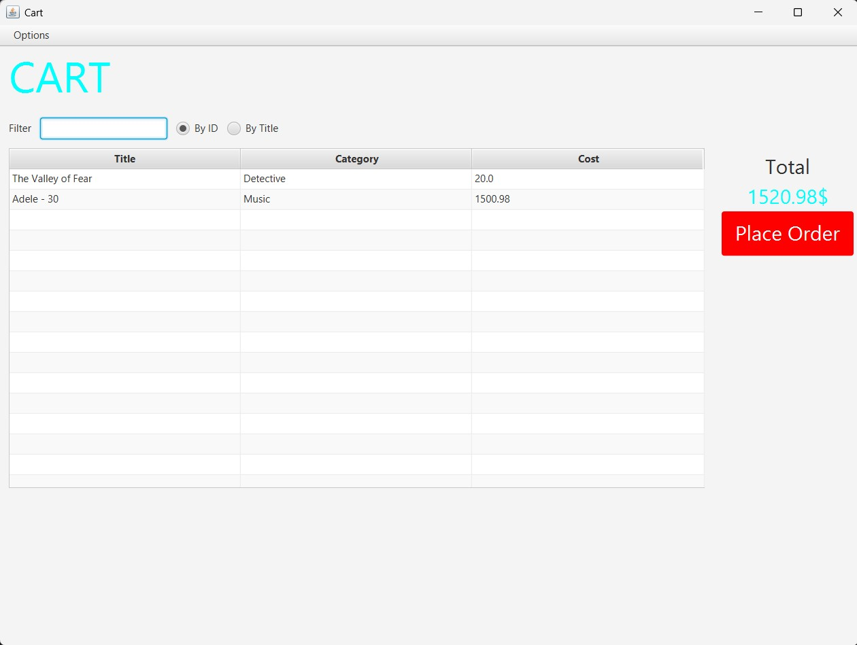

Figure 8.8: Cart

9.Use case Diagram

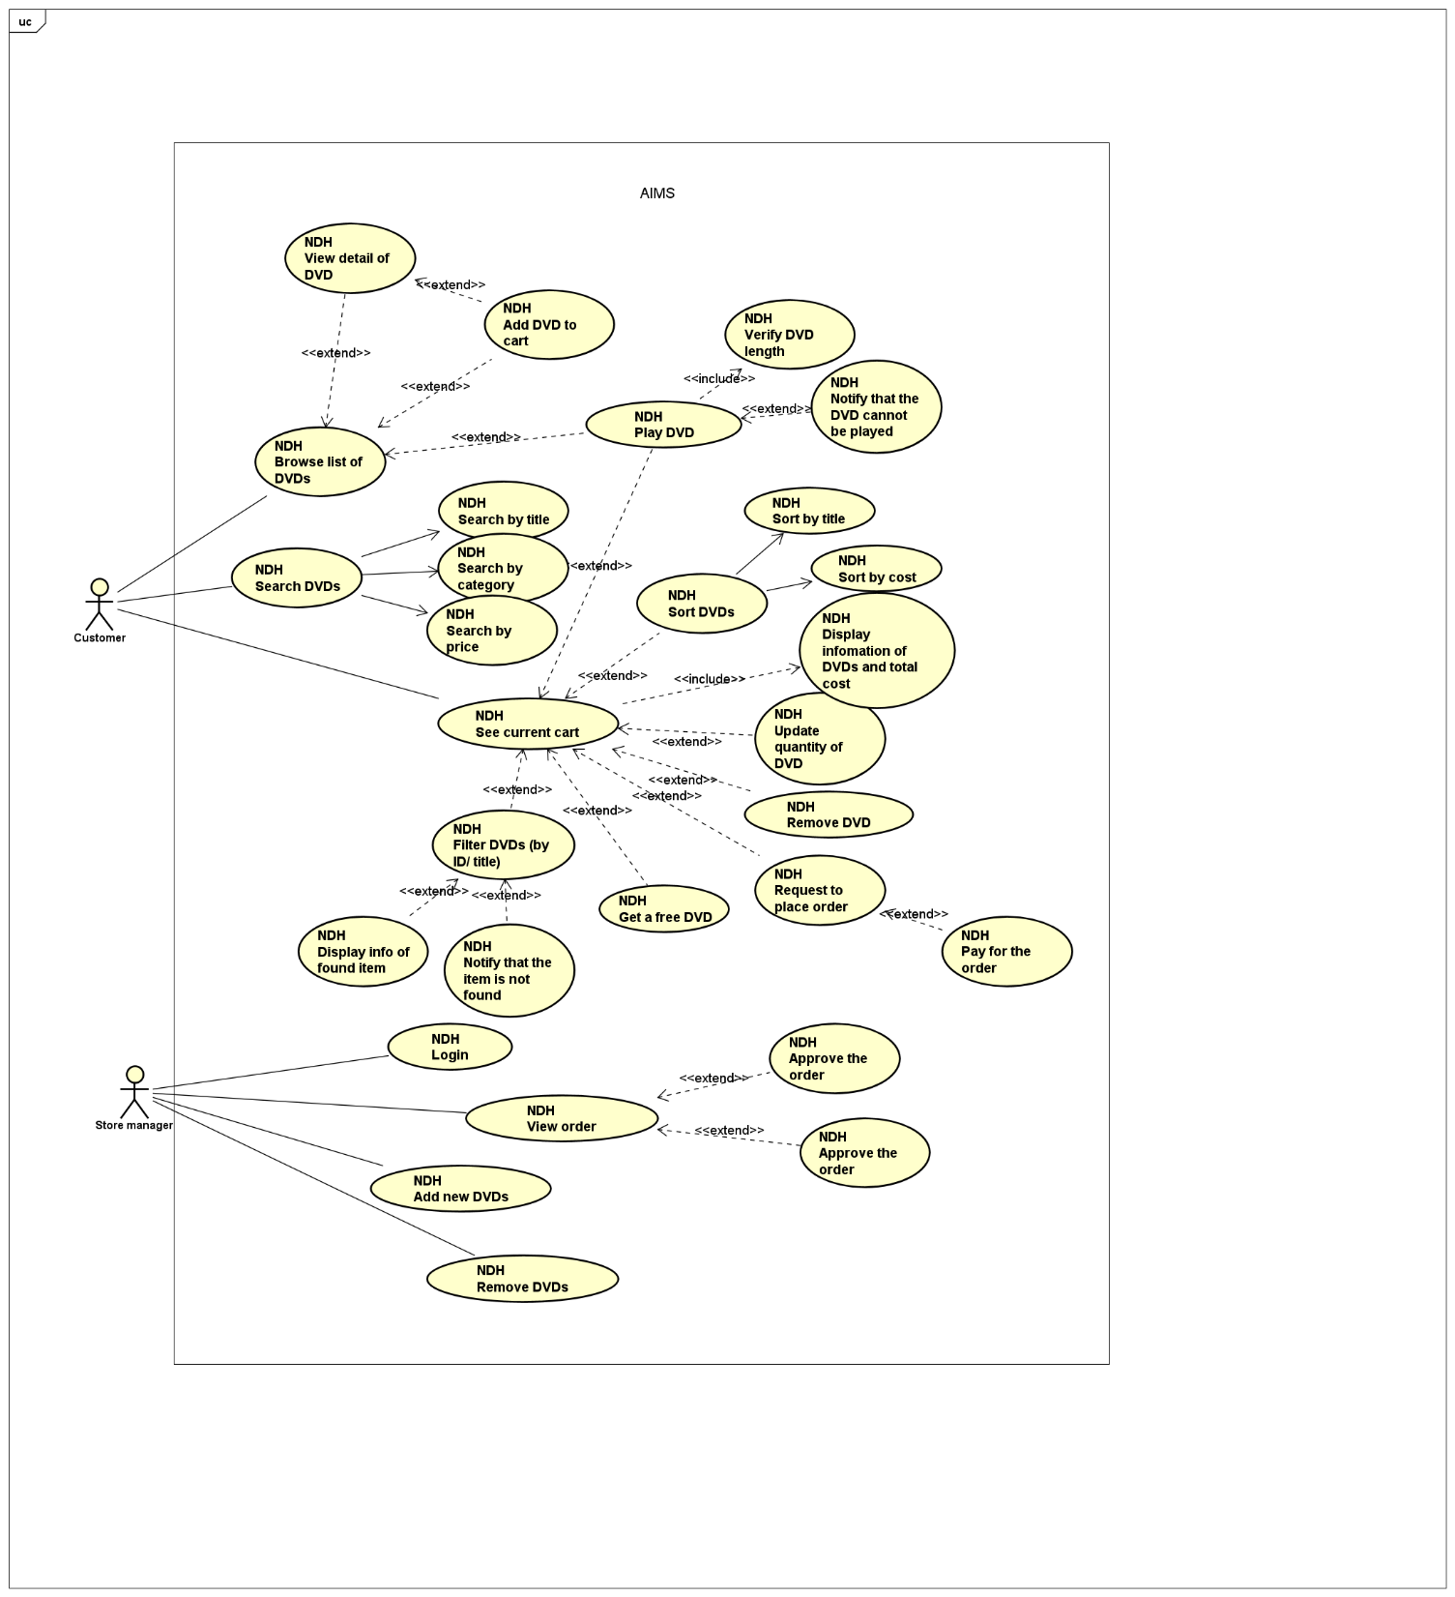

10. Class Diagram
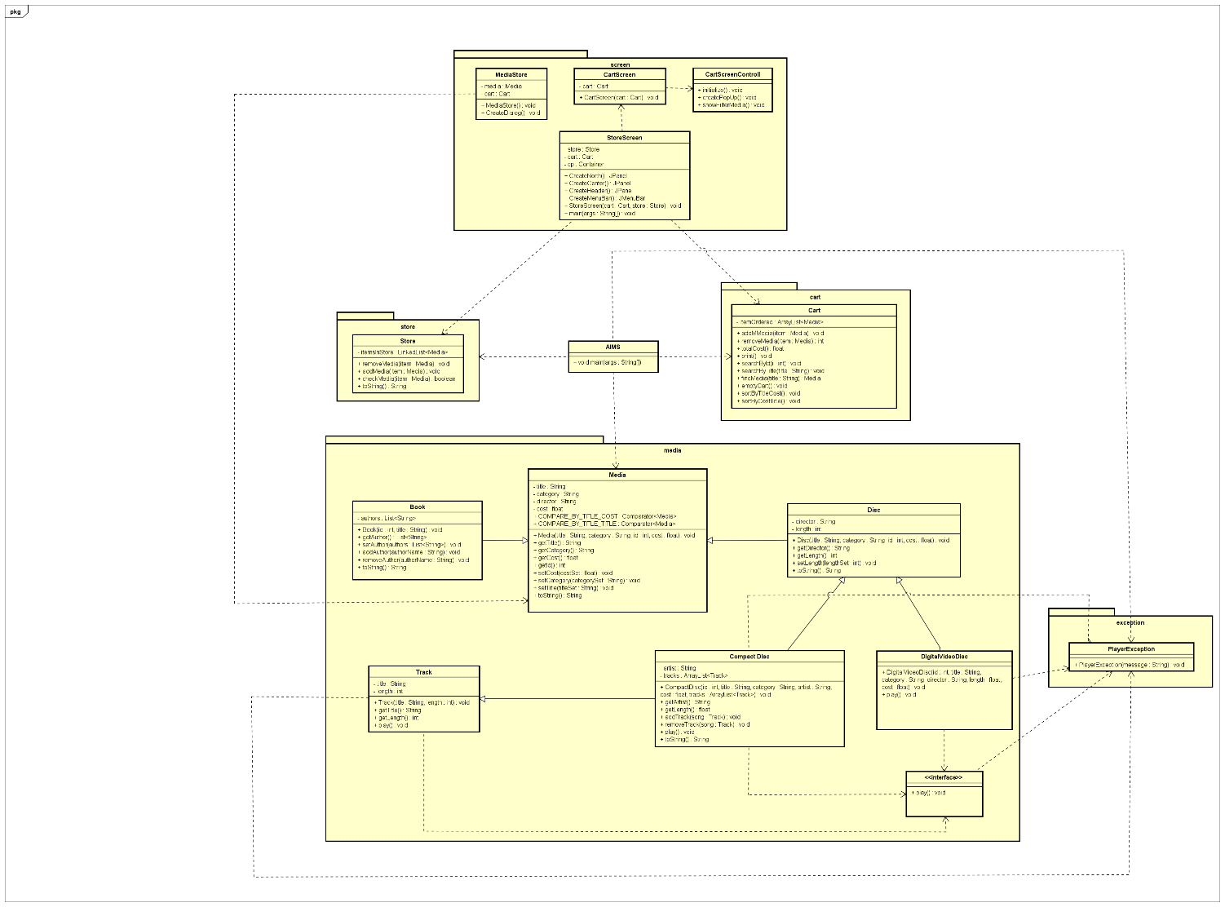

Figure 8.9: Exception

